Directions: Factor the following polynomials by applying the Grouping method.

1) 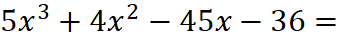 _____________________________

2) 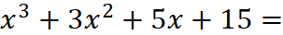 _______________________________

3) 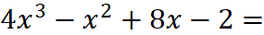 ________________________________

4)  

